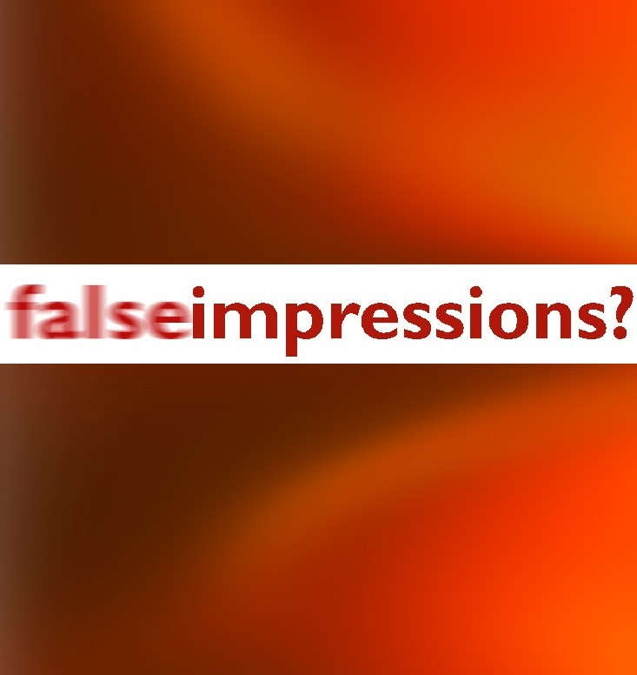 | University Gallery, University of Essex, Colchester, Tel.: 01206-873184  Press Release

False Impressions? asks whether any art can be truly original and whether artists ever escape their debt to tradition. The artists involved have created their own unique works, inspired by famous images, which challenge the viewer’s knowledge of art.

The exhibition runs from 28th May to 21st June at the University Gallery, University of Essex, as part of the MA Gallery Studies course. The private view will be held on Tuesday 27th May from 6pm onwards.

Included are works that are inspired by well known artworks by other artists. These inspirations can be immediately apparent or more subtle. They can derive from appreciation for the underlying work; they can be an homage to another artist or they could carry the meaning of the ‘original’ further, transferring it into a new time. Regardless of whether the ‘originals’ are 50 or 500 years old, no matter whether Renaissance or Pop Art, they are all linked through modern context and contemporary art. The transfer into contemporary art can be shown through the changed media (as for example Rosie James’ work Floppy Stack which uses textiles for Donald Judd’s plexiglass segments) or through slight alterations of the depicted object (Root Cartwright in his Homage - Warhol’s Brides Stripped Bare, a parody of the instantly recognisable Campbell’s soup cans).

False Impressions? forces us to look more closely at what we initially take for granted. The accepted ‘truth’ of the images we see everyday is undermined in the neutral environment of the art gallery. In Monumental Bargain Susan Pui San Lok puts her own ‘label’ onto a pile of T-shirts and parodies the elevated status of fashion by placing them out of reach on a plinth. The artist Keran James will erect the Hollywood sign on the hills above the Gallery, drawing parallels with the production of art and the movies, and the fantasy of both worlds. Reality is questioned in a more literal way by Phil Toy’s Real Slides which, instead of being facsimiles of larger images, are actually beautifully crafted works in themselves.

False Impressions? is both a visually stimulating exhibition, with many striking and powerful images, and a richly textured one which reveals layers of meaning on closer inspection. By bringing these works together we want to direct the viewer’s attention to how we are influenced by the ‘image’ of iconic images. This exhibition is extremely relevant now, when the potential for original thought is being questioned, and should not be missed by anybody with an interest in the future of artistic invention.

